Project on Contact Stresses and Contour Plots

Yifei Shao, Min Joon So

The Cooper Union for the advancement of Science and Art

ME300 Stress and Applied Elasticity

Professor. Kutt

07 Dec 2017

Table of Contents

1. Table of Contents 2
2. Introduction 3
3. Equations 5
4. Approach 6
5. Discussions and Observations 10
6. Conclusions and Applications 14
7. Appendix 16

Introduction

1. **Set up**

Consider a distributed force $P_{0}$ acting over infinite half space. Load $P_{0}$ is applied over $-a≤y≤a, -∞≤z≤∞$. We consider two cases for state of stresses: plane stress $σ_{z}=0$ and plane strain $σ_{z}=v\left(σ_{x}+σ_{y}\right)$.

Plane stress is defined to be a state of stress in which the normal stress, $σ_{z}$, and the shear stresses $τ_{xz} and τ_{yz}$, directed perpendicular to the x-y plane are assumed to be zero. The geometry of a body on which plane stress is applied is essentially that of a plate with one dimension much smaller than the others.

Plane Stress: $\begin{matrix}σ_{x} & τ_{xy} & τ_{xz} \\ τ_{yx} & σ_{y} & 0 \\ 0 & 0 & 0\end{matrix}$

Plane strained is defined to be a state of strain in which the strain normal to the x-y plane and the shear strain $τ_{xz} and τ_{yz}$ are assumed to be zero. In plane strain, one deals with a situation in which the dimension of the structure in one direction, say the z-coordinate direction, is very large in comparison with the dimensions of the structure in the other two directions. Applied forces act in the x-y plane and do not vary in the z direction.

Plane Stress: $\begin{matrix}σ_{x} & τ_{xy} & τ_{xz} \\ τ_{yx} & σ_{y} & 0 \\ 0 & 0 & 0\end{matrix}$

1. **Free body Diagram**

[FBD here]

1. **Materials**

It is given that the material of the body has characteristics of

Young’s Modulus (E) = 200GPa,

Poisson’s Ratio ($v$) = 0.25

yield stress $(σ_{yield})=200MPa$.

1. **Cases:**

There are three cases that we are interested in:

(1) a=1 & plane stress

(2) a=2 & plane stress

(3) a=1 & plane strain.

1. **Find**
2. Stress tensor using superposition
3. Contour plot of $σ_{e}$ in the free body diagram
4. Max values of $\frac{σ_{e}}{P_{0}}$ and location of the maximum
5. Max allowable value of external load ${2aP}_{0}$ and $\frac{P_{0}}{σ_{yield}}$

Equations

[15 governing equations

$$\frac{{∂σ}_{x}}{∂x}+\frac{{∂τ}_{xy}}{∂y}+\frac{{∂τ}_{zx}}{∂z}+b_{x}=0$$

$$\frac{{∂σ}_{y}}{∂y}+\frac{{∂τ}_{yz}}{∂z}+\frac{{∂τ}_{yx}}{∂x}+b_{y}=0$$

$$\frac{{∂σ}_{z}}{∂z}+\frac{{∂τ}_{zx}}{∂x}+\frac{{∂τ}_{zy}}{∂y}+b_{z}=0$$

$$σ_{x}=\frac{∂u}{∂x}, σ_{y}=\frac{∂v}{∂y}, σ_{z}=\frac{∂w}{∂z}$$

$$γ_{xy}=\frac{∂u}{∂y}+\frac{∂v}{∂x}, γ_{yz}=\frac{∂v}{∂z}+\frac{∂w}{∂y}, γ_{zx}=\frac{∂w}{∂x}+\frac{∂u}{∂z}$$

$$σ_{x}=2Gϵ_{x}+λe, σ_{y}=2Gϵ_{y}+λe, σ_{z}=2Gϵ_{z}+\frac{ve}{\left(1+v\right)\left(1-2v\right)}(ϵ_{x}+ϵ_{y}+ϵ_{z})$$

$$σ_{e}=\frac{1}{E}{[σ}_{x}-v{(σ}_{y}+σ_{y})]$$

$$γ_{xy}=\frac{τ_{xy}}{G}, γ_{yz}=\frac{τ_{yz}}{G}, γ_{zx}=\frac{τ_{zx}}{G}$$

$$σ_{e}=\sqrt{\frac{1}{2}{(σ_{x}-σ_{y})}^{2}+\frac{1}{2}{(σ_{y}-σ_{z})}^{2}+\frac{1}{2}{(σ_{z}-σ_{x})}^{2}+3({τ_{xy}}^{2}+{τ_{yz}}^{2}+{τ_{zx}}^{2})}$$

(for $σ_{z}=0) σ_{e}=\sqrt{{σ_{x}}^{2}+{σ_{y}}^{2}-σ_{x}σ_{y}+3{τ_{xy}}^{2}}$

$$σ_{x}=-\frac{2P}{π}\frac{x^{3}}{{\left(x^{2}+y^{2}\right)}^{2}}, σ_{y}=-\frac{2P}{π}\frac{xy^{2}}{{\left(x^{2}+y^{2}\right)}^{2}}, τ_{xy}=-\frac{2P}{π}\frac{yx^{2}}{{\left(x^{2}+y^{2}\right)}^{2}}$$

$$σ_{z}=v(σ_{x}+σ_{y})$$

(Distance h away) $σ_{x}(h)=-\frac{2P}{π}\frac{x^{3}}{{\left(x^{2}+{(y-h)}^{2}\right)}^{2}}$, $σ_{y}=-\frac{2P}{π}\frac{x{(y-h)}^{2}}{{\left(x^{2}+{(y-h)}^{2}\right)}^{2}}, τ_{xy}=-\frac{2P}{π}\frac{(y-h)x^{2}}{{\left(x^{2}+y^{2}\right)}^{2}}$

Approach

1. **Finding stress tensor using superposition**
2. Principle of superposition

Consider a solid body with certain geometry, made of certain materials and supported by certain displacement boundary conditions. This body is being analyzed by the 15 linear governing equations of linear theory of elasticity. The body is subjected to multiple external loading over $-a≤y≤a$.

According to the principle of superposition, if multiple loadings $σ_{x}^{1}, { σ}_{x}^{2}, σ_{x}^{3}, …$ act on the body simultaneously, then solution is $[σ_{x}^{1}+σ_{x}^{2}+σ_{x}^{3}+…]$

1. **Deriving an equation for $σ_{x}(h)$**

We can find $σ_{x}$ (h) where h is the distance from the x axis. Then find the sum using integration over $-a≤h≤a$ on area width of dh.

1. Introduce temporary Cartesian coordinate system $α-β$
2. [drawing]

${σ_{x}}^{a}=-\frac{2Pa}{π}\frac{α^{3}}{{\left(α^{2}+β^{2}\right)}^{2}}$

1. [drawing]

$β=y-h_{0}$

$α=x$

1. Combine steps A & B ,

$$σ_{x}(h)=-\frac{2P}{π}\frac{x^{3}}{{\left(x^{2}+{(y-h_{0})}^{2}\right)}^{2}}$$

The procedure above works the same for $σ_{y} and τ_{x}$:

$$σ_{y}=-\frac{2P}{π}\frac{x{(y-h)}^{2}}{{\left(x^{2}+{(y-h)}^{2}\right)}^{2}}, τ_{xy}=-\frac{2P}{π}\frac{(y-h)x^{2}}{{\left(x^{2}+y^{2}\right)}^{2}}$$

1. **Finding indefinite integrals for $σ_{x}$, $σ_{y}$, $τ_{z} and σ_{z}$**

In MATLAB, int(**expr** , **var**) computes the indefinite integral of **expr** with respect to the symbolic scalar variable **var**. Using int() function, we can find indefinite integrals for $σ_{x}$, $σ_{y}$, $τ_{z}$ as follows:

1. $\sum{σ_{x}}$ = $\int{-\frac{2P}{π}\frac{x^{3}}{{\left(x^{2}+{(y-h)}^{2}\right)}^{2}}dh}$

%Finding improper integral of sigma_x

%INPUT

syms x y h

sigma_x(x,y,h)= -2P/pi*int(x^3/(x^2+(y-h)^2)^2, h)

%OUTPUT

sigma_x(x, y, h) =

**-2*P/pi*{atan((h - y)/x)/2 + (x*(h - y))/(2*(x^2 + (h - y)^2))}**

$\sum{σ_{x}}$ = ${\left[-\frac{2P}{π}\frac{\operatorname{atan}\left(\frac{h-y}{x}\right)}{2}+\frac{x\left(h-y\right)}{2(x^{2}+{\left(h-y\right)}^{2})}\right]}_{-a}^{a}$

sig_x =sigma_x(x,y,h_upper)-sigma_x(x,y,h_lower);

1. $\sum{σ_{y}}$ = $\int{-\frac{2P}{π}\frac{{x(y-h)}^{2}}{{\left(x^{2}+{(y-h)}^{2}\right)}^{2}}dh}$

%Finding improper integral of sigma_y

%INPUT

syms x y h

sigma_y(x,y,h)= -2P/pi*int((y-h)^2*x/(x^2+(y-h)^2)^2, h)

%OUTPUT

sigma_y(x, y, h) =

**-2*P/pi*((atan((h - y)/x)/2 - (x*(h - y))/(2*(x^2 + (h - y)^2))))**

$\sum{σ_{y}}$ = ${\left[-\frac{2P}{π}\frac{\operatorname{atan}\left(\frac{h-y}{x}\right)}{2}-\frac{x\left(h-y\right)}{2(x^{2}+{\left(h-y\right)}^{2})}\right]}_{-a}^{a}$

sig_y =sigma_y(x,y,h_upper)-sigma_y(x,y,h_lower);

1. $\sum{τ_{xy}}$ = $\int{-\frac{2P}{π}\frac{{(y-h)x}^{2}}{{\left(x^{2}+{(y-h)}^{2}\right)}^{2}}dh}$

%Finding improper integral of tax_xy

%INPUT

syms x y h

tau_xy(x,y,h)= -2P/pi*int((y-h)*x^2/(x^2+(y-h)^2)^2, h)

%OUTPUT

sigma_x(x, y, h) =

**-2*P/pi*(x^2/(2*(x^2 + (h - y)^2)))**

$\sum{τ_{xy}}$ = ${\left[-\frac{2P}{π}\frac{x^{2}}{2(x^{2}+{\left(y-h\right)}^{2})}\right]}_{-a}^{a}$

t_xy =tau_xy(x,y,h_upper)-sigma_y(x,y,h_lower);

$\sum{σ_{z}}=\sum{v(σ_{x}+σ_{y})}$

sig_z=bool_sig_z*v*(sig_x+sig_y);

* sig_x, sig_y, t_xy and sig_z represents the net $σ_{x}$, $σ_{y}$, $τ_{xy}$ and $σ_{z}$ at coorindate (x , y) over the area bounded by $-a≤y≤a, -∞≤z≤∞$. h_upper is the maximum value of h, which is ‘a’, and h_lower is the minimum value of h, ‘-a’.

1. **Plotting contour of $σ_{e}$**

Given the equation [$σ_{e}$ =], we can find $σ_{e}$ at any coordinate (x , y). To plot a contour of $σ_{e}$, we are going to iterate in MATLAB from $x_{min}=0$ to $x_{max}=8$ and from $y_{min}=-a$ to $y_{max}=a$ using a hundred steps for each axis. In addition, as we iterate through x and y axis within the given boundary, we can compare each value of $σ_{e}$ to find the maximum. We do so as follows:

%sigma_e= @(sig_x,sig_y,sig_z,t_xy)(0.5*(sig_x-sig_y).^2+0.5*(sig_y-sig_z).^2+0.5*(sig_z-sig_x).^2+3*(t_xy).^2).^(0.5);

steps=100;

for i= 1:steps %

for j= 1:steps

x=x_max/steps*(i-1);

y=-y_max+2*y_max/steps*(j-1);

X(i)=x;

Y(j)=y;

sig_x =sigma_x(x,y,h_upper)-sigma_x(x,y,h_lower);

sig_y =sigma_y(x,y,h_upper)-sigma_y(x,y,h_lower);

sig_z=bool_sig_z*v*(sig_x+sig_y);

t_xy =tau_xy(x,y,h_upper)-tau_xy(x,y,h_lower);

sig_e(i,j)=sigma_e(sig_x,sig_y,sig_z,t_xy);

if abs(sig_e(i,j)) > sig_max %finds max of sig_e

sig_max = sig_e(i,j);

x_peak=x;

y_peak=y;

end

end

end

1. **Finding the maximum values of $\frac{σ_{e}}{P_{0}}$ and their locations**

From the MATLAB program above, we have iterated from $x_{min}$ to $x_{max}$ and $y_{min}$ to $y_{max}$ and saved the maximum value of $σ_{e}$ in the sig_max variable and its x and y coordinates in x_peak and y_peak. We simply access the values stored in each variable. Specific numerical values and analysis are shown in the appendix.

1. **Finding the maximum allowable value of external load ${2aP}_{0}$ and $\frac{P_{0}}{σ_{yield}}$**

The maximum allowable value of external load ${2aP}_{0}$ can be calculated using the following equation:

${2aP}_{0}=2a×$ $σ_{yield}/σ_{e max}$

$$\frac{P_{0}}{σ_{yield}}=\frac{1}{σ_{e max}}$$

%MATLAB representation of the equations above

sig_max_over_P0 = sig_max/P

max_load_per_sq_m = sig_yield/sig_max_over_P0

max_load_per_m = 2*a*max_load_per_sq_m

p_over_sig_yield = max_load_per_sq_m/sig_yield

Discussions and Observations

Plain stress analysis can be used for a plate with one dimension (i.e. thickness) much smaller than the others. The key assumption is that stresses are zero through thickness and the in-plane stresses are constant through thickness in a component. One of the advantages of using plane stress analysis is that it is strictly 2-dimensional analysis, so only three degrees of freedom have to be constrained.

Plain strain analysis makes subtly different assumptions: strain through thickness is set to zero. In practice, we use this method where the stress state is varying slowly from plane to plane in a deep component. Some important practical applications of plane strain analysis occur in the analysis of dams, tunnels, and other geotechnical works in which the dimension of the structure in one direction is very large in comparison with the dimensions of the structure in the other two directions.

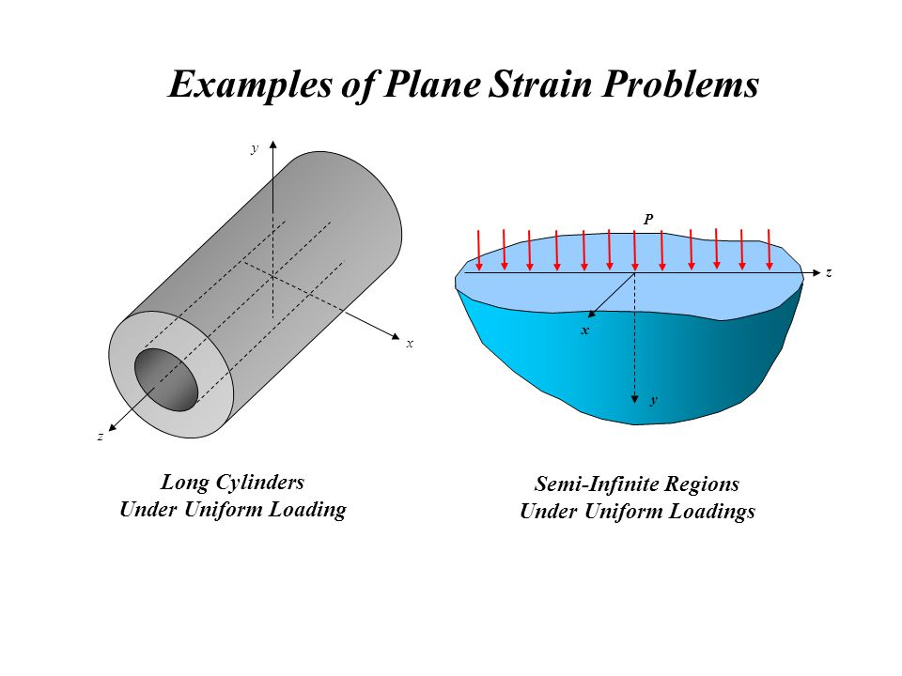

1. **Comparing with the line load case (concentrated load) derived in class (y=0)**

|  |  |  |  |
| --- | --- | --- | --- |
| **Depth x**  (m) | **Line Load**: Stress/ $P_{0}$ (Pa/N) | **Area Load**:  Plane Stress/ $P_{0}$ (Pa/N) | **Area Load**:  Plane Strain/ $P_{0}$ (Pa/N) |
| 0 | $$∞$$ | 1 | 0.5 |
| 1 | 0.64 | 0.73 | 0.60 |
| 2 | 0.32 | 0.53 | 0.46 |
| 3 | 0.21 | 0.38 | 0.34 |

*a=1 is used for the analysis of area loads

1. From the chart above, we can tell that, in the three conditions, the line load has the highest peak $σ_{e}$ at the point of load application. However, the stress in line load has the quickest decaying speed as well, i.e. at x = 3 m line load stress has 21% of the magnitude of the load, while both area load have 38% and 34% percent of the magnitude of the load.
2. The area load - plane strain case also exhibit a noticeable difference from the other two cases: The maximum value of $σ_{e}$ exists not at the point/line of application but below it at around x = 0.88 (given y = 0)
3. All three stress profiles are similar in that on the surface of the half space where there’s no load, $σ_{e}$ = 0.
4. **Comparing the plane stress case for the two different values of load area**

|  |  |  |
| --- | --- | --- |
| **Depth x**  (m) | **Area Load (a=1):** Plane Stress/ $P_{0}$ (Pa/N) | **Area Load (a=2):**  Plane Stress/ $P_{0}$ (Pa/N) |
| 0 | 1 | 1 |
| 1 | 0.73 | 0.82 |
| 2 | 0.53 | 0.74 |
| 3 | 0.38 | 0.63 |

1. These two cases are similar in that the maximum effective stress both exist at x=0, where the load is applied on each area. The magnitude of the effective stress is equal to the load applied on the unit area.
2. The effective stress with greater area of load applied decays slower as x increases.
3. **Comparing the plane stress case vs. plane strain case**

|  |  |  |
| --- | --- | --- |
| Category | Area Load - Plane Stress/ $P_{0}$ (Pa/N) | Area Load - Plane Strain/ $P_{0}$ (Pa/N) |
| Max Location (m) | x = 0 ;  -a < y < a | x =0.56 ; y = 0.72 and y =-0.72 |
| Max Magnitude | 1 | 0.6101 |
| x = 0 , y = 0 | 1 | 0.5 |
| x = 1,  y = 0 | 0.73 | 0.60 |
| x = 2,  y = 0 | 0.53 | 0.46 |
| x = 3,  y = 0 | 0.38 | 0.34 |

1. The most significant difference between these two stress profiles is the location of the max value. For the Plane Stress case, the max values exist along the line where the load is applied (at x = 0). For the Plane Strain case, the max value exist at two points where x = 0.56, symmetric about y = 0. Furthermore, from examining the surface plot in the Plane Strain case,we see that there is a curve where the stress is 99.98% of the max stress.

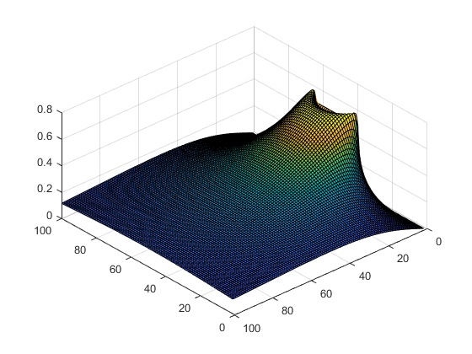

1. The attached figure is generated by subtracting $σ_{e}$ caused by plane strain from $σ_{e}$ caused by plane stress. We can see that the difference shows that $σ_{z}$ contributed to the difference most at x = 0 and have less contribution as x increase and the absolute value of y increase. An alternative way of saying this is these two stress profiles have the most difference at x = 0 (delta = 0.5), and the difference decrease in magnitude as x increase (x = 3, delta = 0.04)

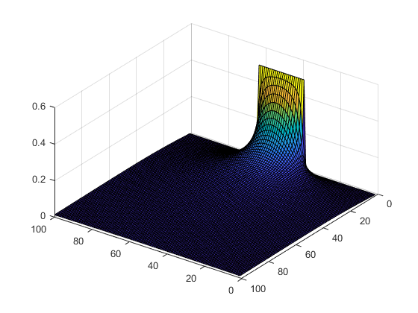

Conclusions & Applications

1. **Stress tensor due to the load**

[stress tensor]

1. **Contour plot of $σ_{e}$ in the free body diagram**

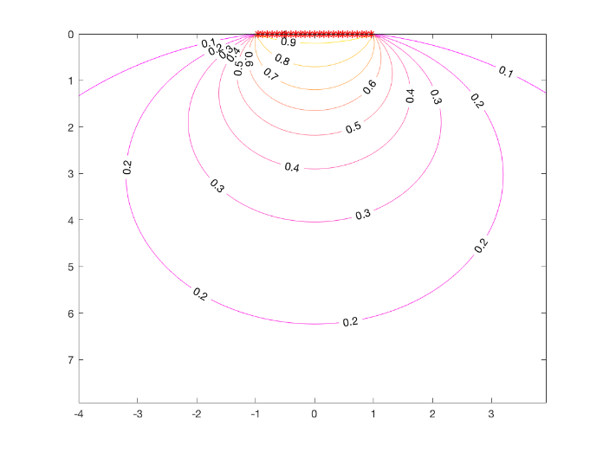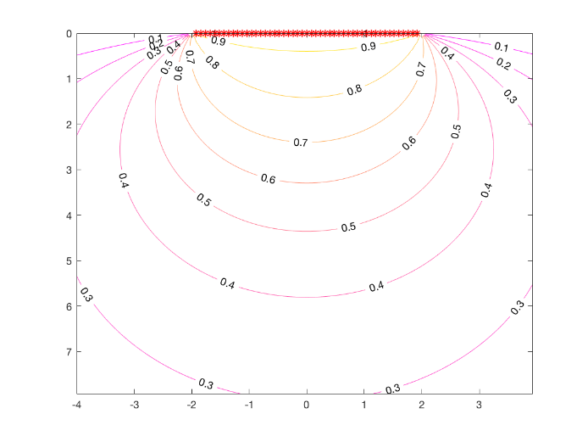

                            (1) plane stress a = 1 (2) plane stress a = 2

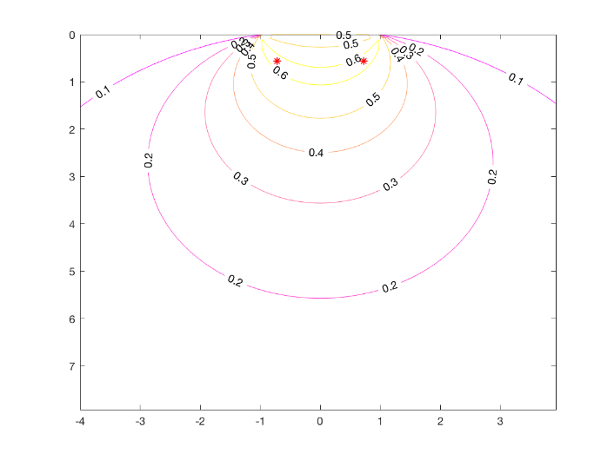  
(3) plane strain a = 1

1. **Max values of $P_{0}σ_{e}$ and location of the maximum**
2. plane stress a=1: 1.00
3. plane stress a=2: 1.00
4. plane strain a=1: 0.6101
5. **Max allowable value of external load 2a $P_{0}$ and $P_{0}σ_{yield}$**
6. plane stress a=1 $: 4.00×{10}^{4}$ N/m  and 1.00
7. plane stress a=2: $8.00×{10}^{8}$   N/m  and 1.00
8. plane strain a=1: $6.54×{10}^{8}$   N/m  and 1.64
9. **Applications**
10. One of the application of the stress result of this loading condition is when an engineer designs the contact area of a wheel with the road.

$P_{0}$ = $\frac{load on a wheel}{contact area underload}$.

Using the plane strain result, we can conclude that the yield stress of the road has to be above $0.61×p_{0}×FS$.

1. When designing the ice skating blades, it is crucial that the stress on the surface of the ice reaches above a certain limit so that the ice melts, acting as lubrication for the skater. For the plane strain case, the max stress on the surface is $p_{0}×0.5$.

Appendix